**JSS MAHAVIDYAPEETHA**

**JSS SCIENCE AND TECHNOLOGY UNIVERSITY**

JSS Technical Institutions Campus, Mysuru – 570006

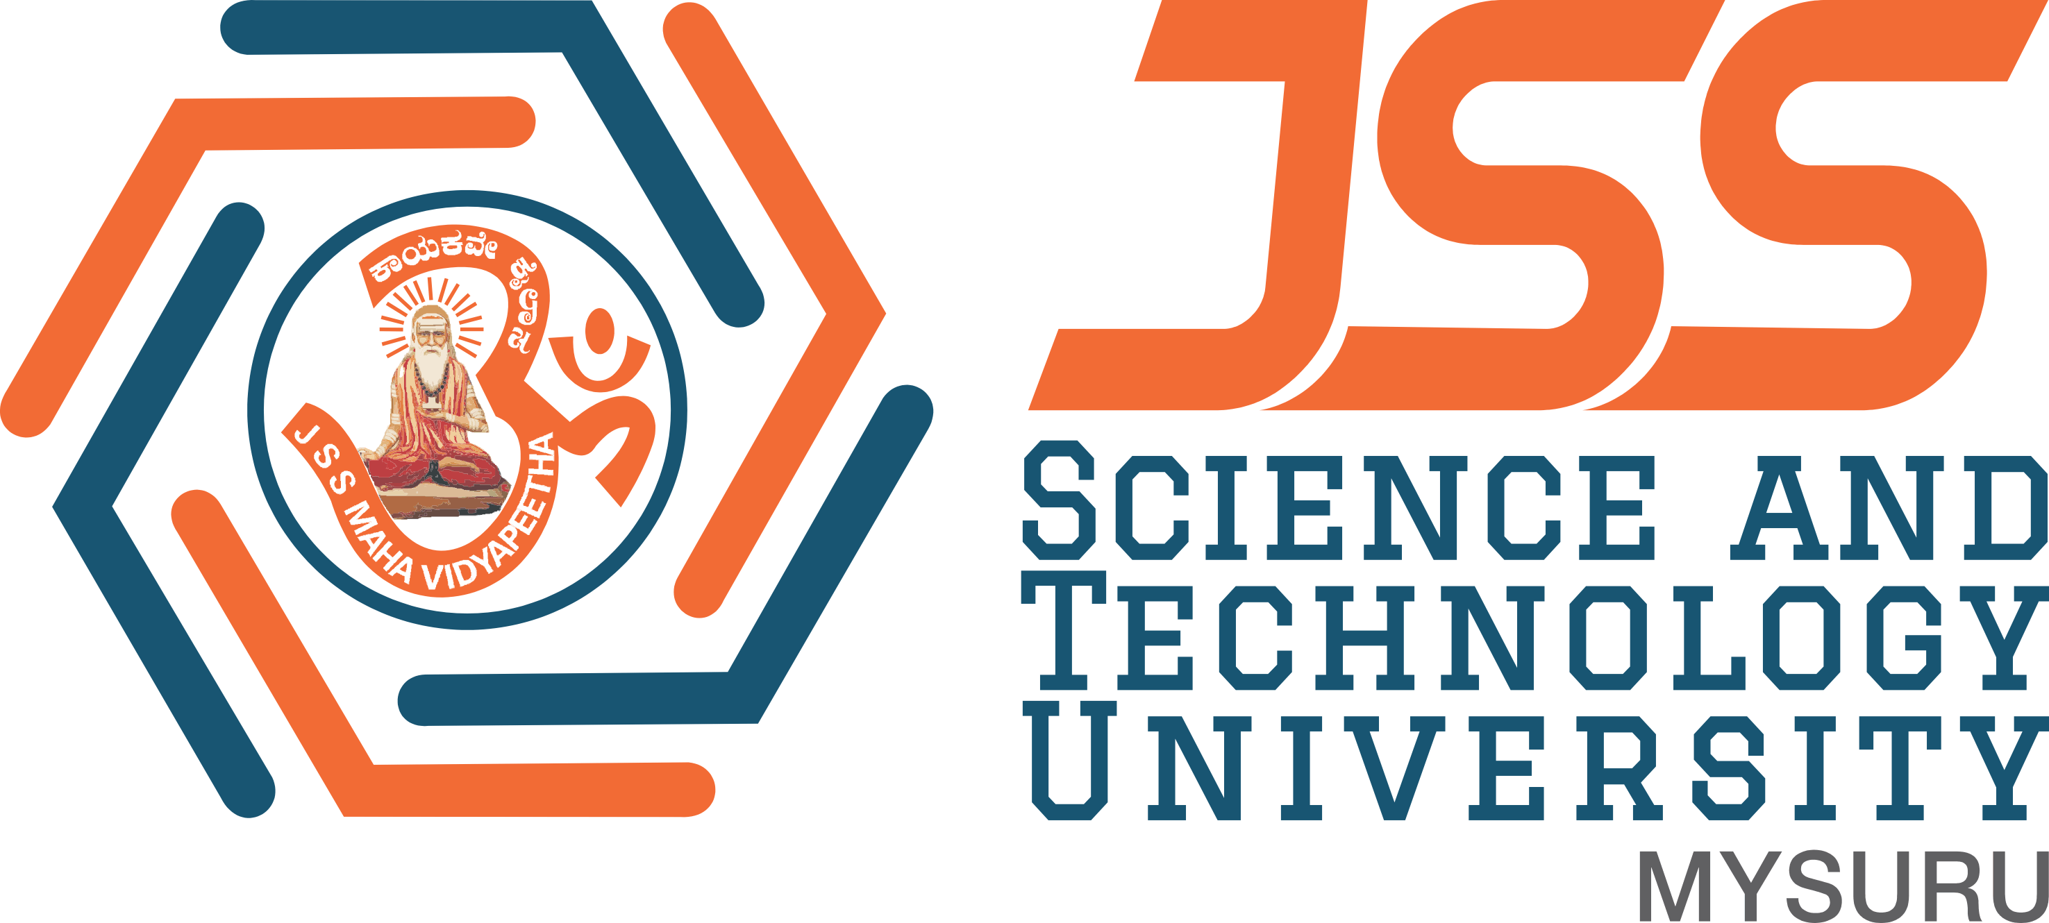

**“Blood Bank Management System”**

Mini project report submitted in partial fulfillment of curriculum prescribed for the Database Management Systems (20CS510) course for the award of the degree of

#### BACHELOR OF ENGINEERING

**IN**

**COMPUTER SCIENCE AND ENGINEERING**

*by*

# **Abhijith Iyer R Niraj S Dalavi**

**(01JST20CS001) (01JST20CS104)**

# **Spoorthi S Rao Sriraam K**

**(01JST20CS157) (01JST20CS159)**

*Under the Guidance of*

#### Dr. Trisiladevi C. Nagavi

Associate Professor,

Dept.of CS & E, SJCE, JSS STU Mysore

**DEPARTMENT OF COMPUTER SCIENCE AND ENGINEERING**

**December 2022**

|  |  |  |
| --- | --- | --- |
|  |  |  |

**JSS MAHAVIDYAPEETHA**

**JSS SCIENCE AND TECHNOLOGY UNIVERSITY**

JSS Technical Institutions Campus, Mysuru – 570006



**CERTIFICATE**

This is to certify that the work entitled “Blood Bank Management System” is a bona fide work carried out by Abhijith Iyer R , Niraj S Dalavi, Spoorthi S Rao, and Sriraam K in partial fulfillment of the award of the degree of Bachelor of Engineering in Computer Science and Engineering of JSS Science and Technology, Mysuru during the year 2024. It is certified that all corrections / suggestions indicated during CIE have been incorporated in the report. The mini project report has been approved as it satisfies the academic requirements in respect of mini project work prescribed for the Database Management Systems (20CS510) course.

## Course in Charge and Guide

#### Dr. Trisiladevi C. Nagavi

Associate Professor,

Dept.of CS & E, JSS STU Mysore

**Place:** Mysore **Date :**